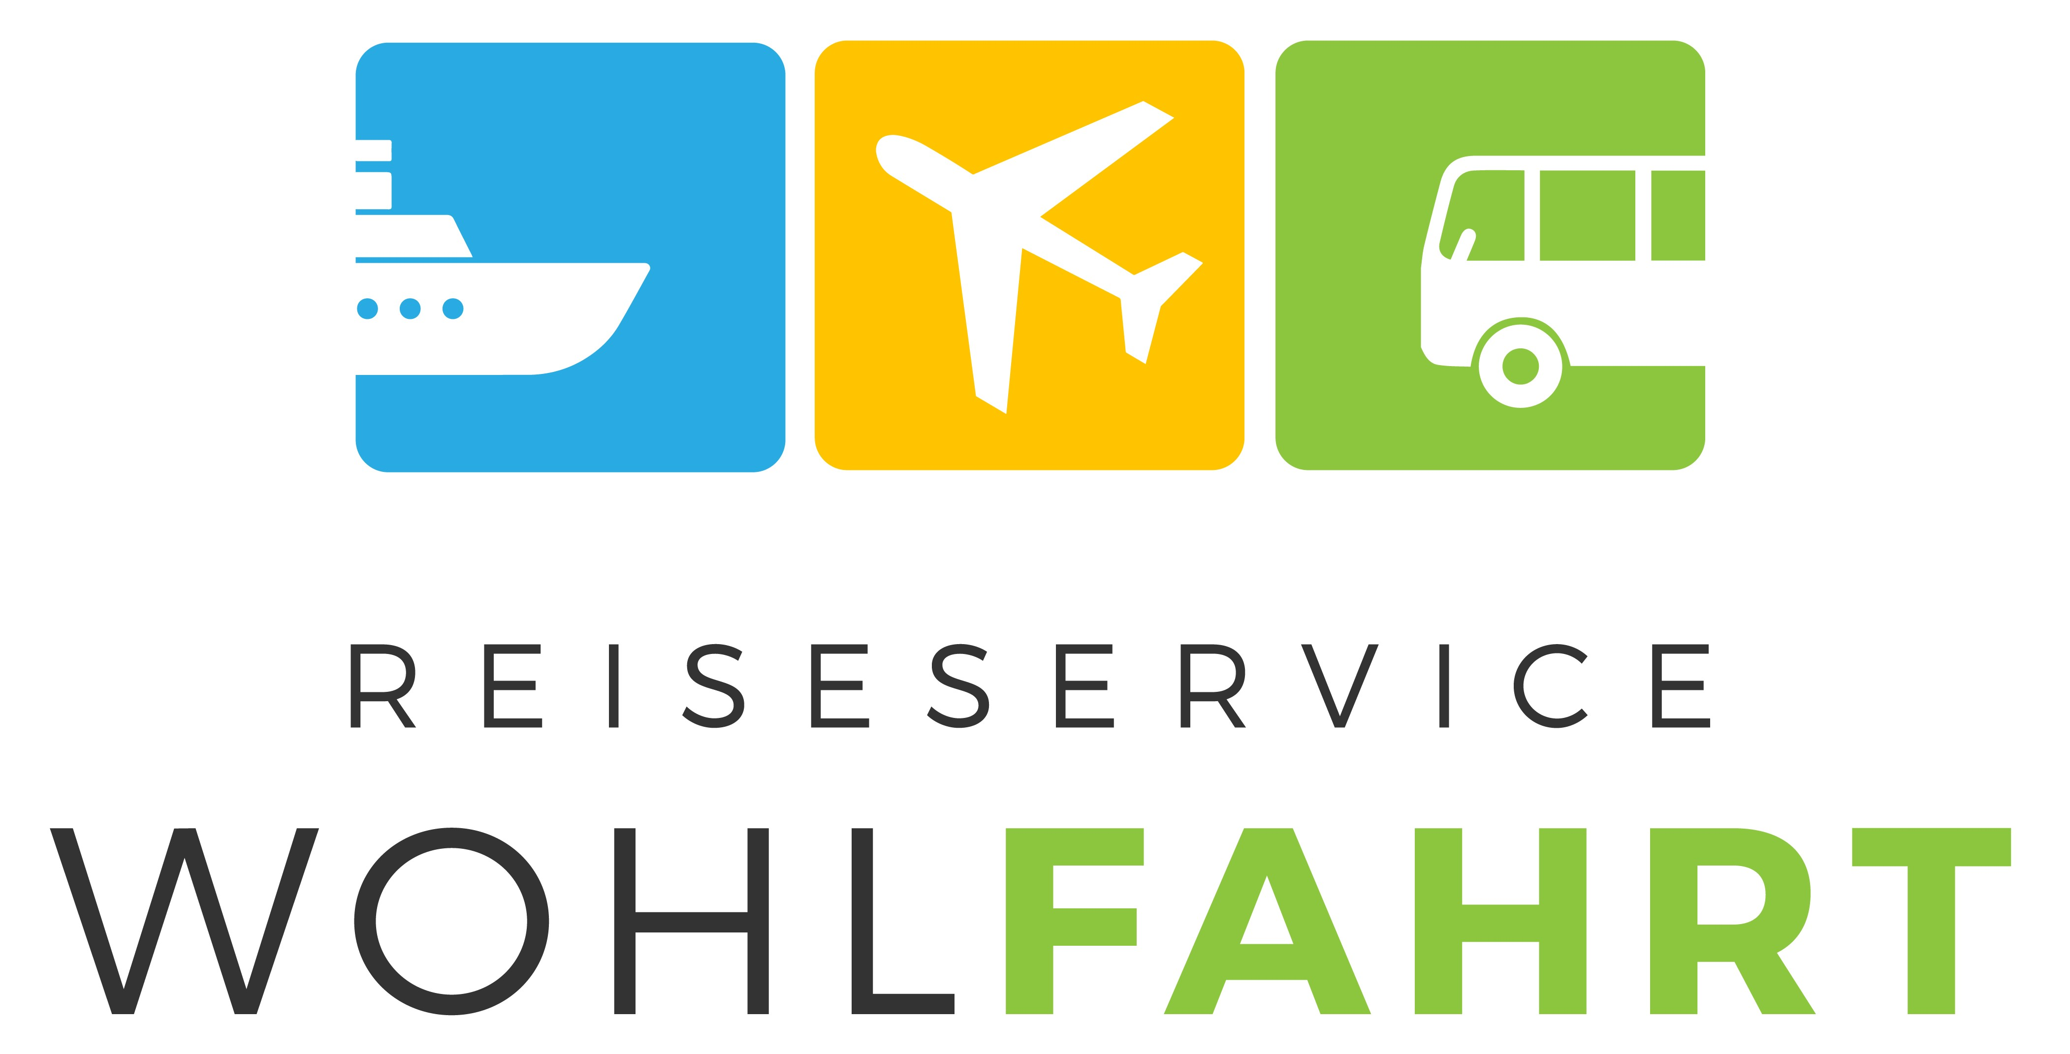**PROGRAM**

**Berlin**

**Constructor University Bremen**

**Fall Semester – This trip usually takes place the 2nd or 3rd weekend of October**

[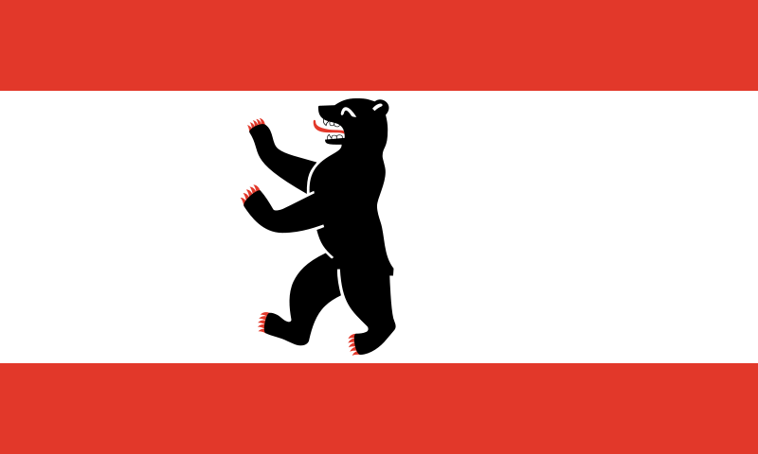](http://upload.wikimedia.org/wikipedia/commons/e/ec/Flag_of_Berlin.svg) **Thursday - Day 1**

06:45 Meeting at the main gate, Jacobs University

07:00 Departure to Berlin

12:30 Arrival at Berlin Central Bus Station (Berlin ZOB/Zoo),

Lunch break/Leisure time

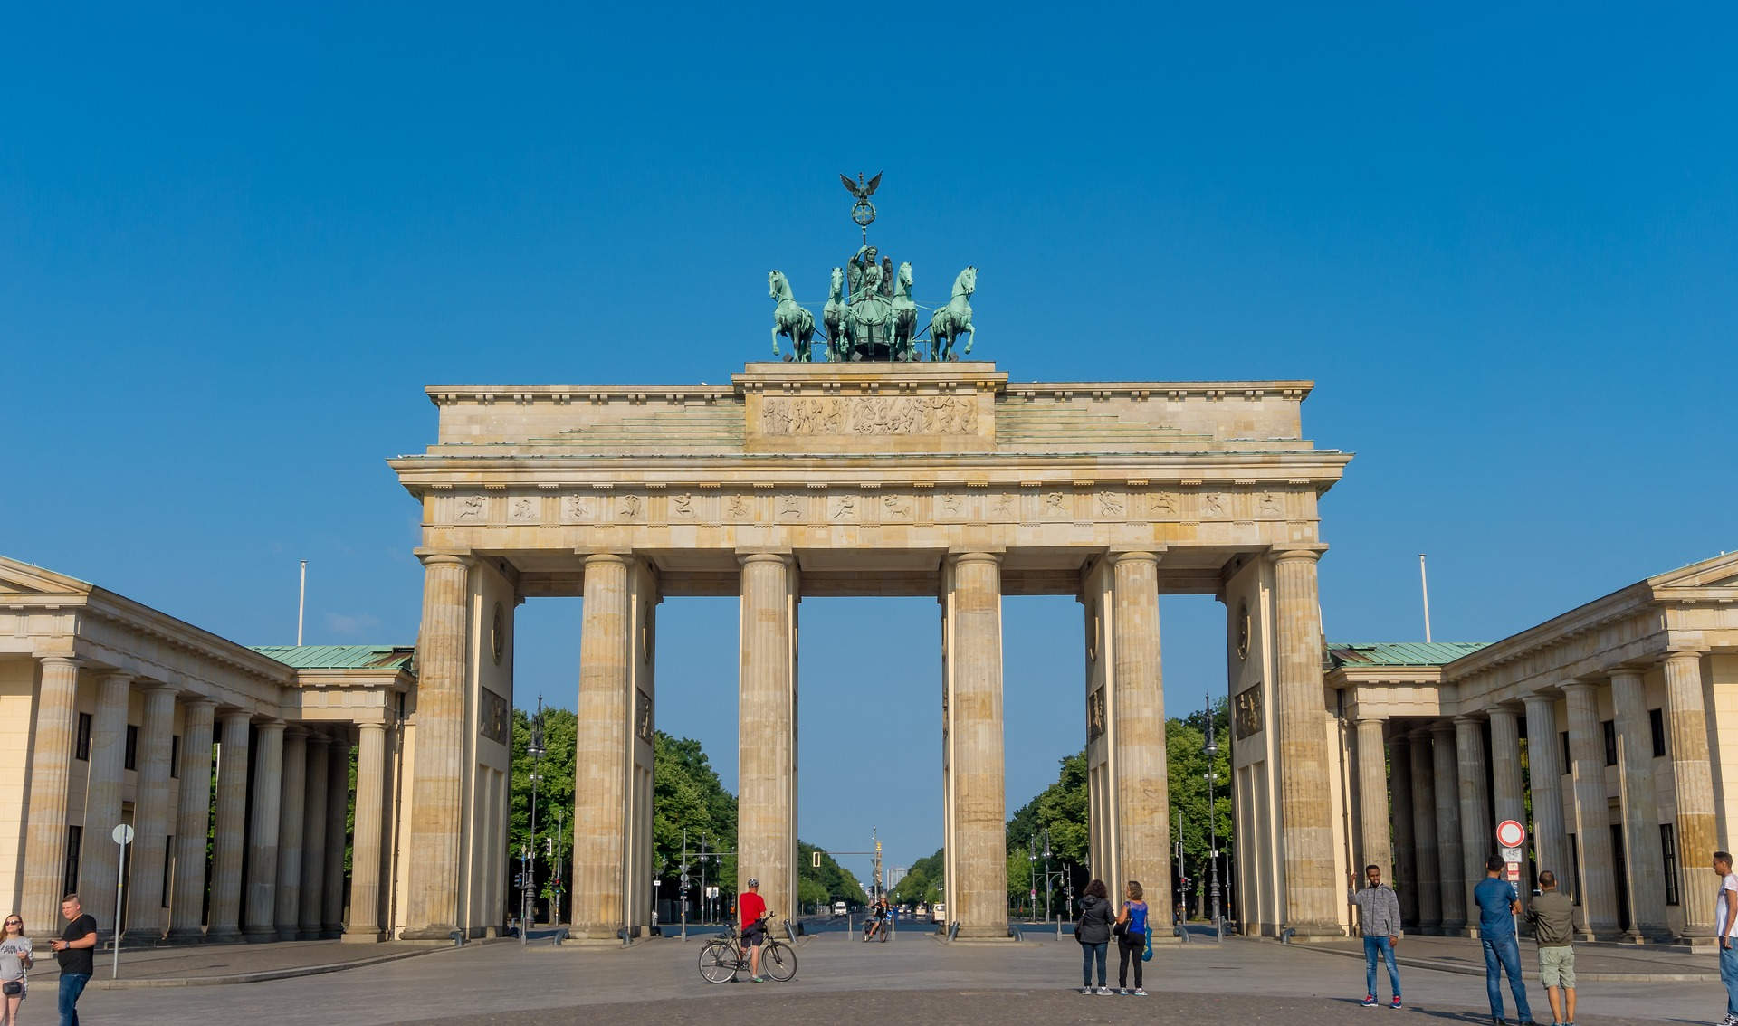

13:30 City tour through Berlin (3 hours)

17:00 Check-in to accommodation

19:00 Dinner

20:30 Leisure time

Ein Bild, das Gras, draußen, Verwaltungsgebäude, Stein enthält.
**Friday – Day 2**

until 10:30 Breakfast (starts at 6:30 a.m.)

12:30 Departure to Paul-Löbe-Haus

13:15 Check-in at Paul-Löbe-Haus

14:00 Meeting with Dr. Kirsten Kappert-Gonther (Bündnis 90/Die Grünen), Chairwoman of the Committee on Health of the German Bundestag

15:30 Leisure time / Departure to accommodation

**Saturday - Day 3**

until 10:00 Breakfast (starts at 7:30)

Ein Bild, das draußen, Wasser, Himmel, Natur enthält.

10:15 Departure to Charité, Berlin Museum of Medical History

11:00 Guided tour through the permanent exhibition “Tracing Life” at the Museum of Medical History at Charité

12:30 Departure to Potsdamer Platz

Lunch break/Leisure time

[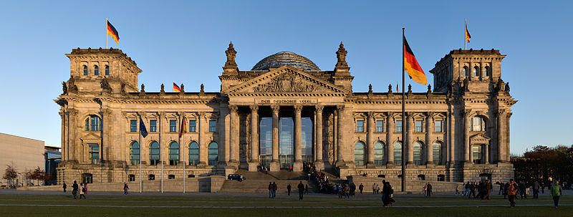](http://upload.wikimedia.org/wikipedia/commons/c/c7/Reichstag_building_Berlin_view_from_west_before_sunset.jpg)

16:00 Departure to Reichstag

16:30 Check-in at central entrance for visitors at Scheidemann-Street

17:00 Guided tour Reichstag (1,5 hours)

19:00 Leisure time / Departure to accommodation

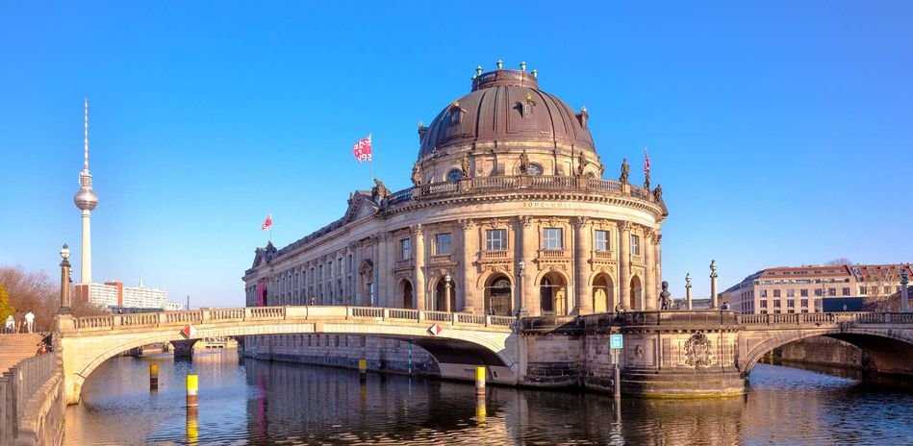**Sunday, Day 4**

until 09:00 Breakfast (starts at 7:30 a.m.)

09:15 Check-out of accommodation

09:30 Departure to Museum Island

10:00 Visit of the New Museum at Museum Island

12:30 Meeting and departure to Berlin Hauptbahnhof

Lunch break/Leisure time

14:00 Departure to Bremen

19:30 Arrival in Bremen